Date: November 26, 2003

High Speed Dental Radial Bearings for handpiece
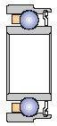
The most popular item numbers in the market.

ID: 3.175 KAVO : 628
OD: 6.35 / 5.979
Width: 2.38
RPM : 400.000 C93KXA
----------------------------------------------------------------------------------------------------------------------------------------
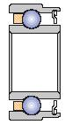
ID: 3.175 KAVO : 625
OD: 6.35 / 5.979
Width: 2.779
RPM : 400.000 ST-R3
---------------------------------------------------------------------------------------------------------------------------------------
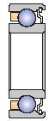
ID: 3.175 MIDWEST
OD: 6.35
Width: 2.38
RPM : 400.000 S418MCKH
----------------------------------------------------------------------------------------------------------------------------------------
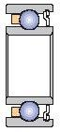
ID: 3.175 WH
OD: 6.35
Width: 2.779
RPM : 400.000 WH
----------------------------------------------------------------------------------------------------------------------------------------

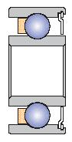
ID: 3.175 BIENAIR
OD: 7.938
Width: 3.571
RPM : 400.000 DCMB
----------------------------------------------------------------------------------------------------------------------------------------
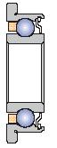
ID: 3.175 NSK
OD: 7.5 / 6.35
Width: 2.779
RPM : 400.000 S418FMCKH
----------------------------------------------------------------------------------------------------------------------------------------

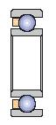
ID: 3.175 LARES handpiece
OD: 6.35
Width: 1.91
RPM : 400.000

Resource: www.ntbp.com/dentalbearing

